**LEARN EASE**

A Full Stack Development Report

Submitted in partial fulfillment of the

Requirements for the award of the Degree of

**BACHELOR OF ENGINEERING**

**IN**

**INFORMATION TECHNOLOGY**

By

Harika Narla(1602-22-737-015)

Jahnavi Guntuboina(1602-22-737-018)

Joyce Gd (1602-22-737-020)



**Department of Information Technology**

**Vasavi College of Engineering (Autonomous)**

**ACCREDITED BY NAAC WITH ‘A++’ GRADE**

**(Affiliated to Osmania University & Approved by AICTE) Ibrahim Bagh, Hyderabad-31**

**2023**

**Vasavi College of Engineering (Autonomous)**

**(Affiliated to Osmania University)**

**ACCREDITED BY NAAC WITH ‘A++’ GRADE**

**(Affiliated to Osmania University and Approved by AICTE)**

**Hyderabad-500031**

**Department of Information Technology**

**DECLARATION BY THE CANDIDATE**

We, **Harika Narla, Jahnavi Guntuboina, Joyce Gd**, bearing hall ticket number, **1602-22-737-015, 1602-22-737-018, 1602-22-737-020 hereby** declare that the project report entitled “Learn Ease” is submitted in partial fulfillment of the requirement for the award of the degree of **Bachelor of Engineering** in **Information Technology**.

This is a record of Bonafide work carried out by us and the results embodied in this project report have not been submitted to any other university or institute for the award of any other degree or diploma.

Harika Narla

(1602-22-737-015)

Jahnavi Guntuboina

(1602-22-737-018)

Joyce Gd

(1602-22-737-020)

(Faculty In-Charge) (Head. Dept. of IT)

**ACKNOWLEDGEMENT**

We extend our sincere thanks to Dr. S. V. Ramana, Principal, Vasavi College of Engineering for his encouragement.

We express our sincere gratitude to Dr. K. Ram Mohan Rao, Professor & Head, Department of Information Technology, Vasavi College of Engineering, for introducing the Mini-Project module in our curriculum, and also for his suggestions, motivation, and co-operation for the successful completion of our Mini Project.

We also want to thank and convey our gratitude towards our mini project coordinator **Ms.Aruna** for guiding us in understanding the process of project development & giving us timely suggestions at every phase.

We would also like to sincerely thank the project reviewers for their valuable input and suggestions.

ABSTRACT:

Our portal, Learn Ease, serves as a centralized hub for placement questions. This platform is designed to enhance the preparation process for students by offering a comprehensive suite of tools that include quizzes, assignments, daily questions, and interactive features. The portal aims to provide a user-friendly experience for both students and administrators, facilitating an efficient and engaging learning environment.

**Features**

1. **User Authentication (Administrator & Students)**
   * **Description:** The portal includes a secure authentication system that allows both administrators and students to log in to the platform. Administrators have access to all the features and can manage the content, while students have access to quizzes, assignments, and daily questions.
   * **Benefits:** Ensures secure access and personalized user experience, allowing different levels of access based on user roles.
2. **Interactive Dashboard**
   * **Description:** The dashboard provides an intuitive interface where users can navigate through various features of the portal. It displays important information such as upcoming quizzes, pending assignments, and recent activity.
   * **Benefits:** Enhances user engagement and makes it easier for students to keep track of their progress and for administrators to manage the platform efficiently.
3. **Quizzes and Assignment (Conduction and Submission)**
   * **Description:** The portal allows administrators to create and assign quizzes and assignments. Students can take quizzes and submit assignments directly through the platform.
   * **Benefits:** Streamlines the process of conducting and submitting assignments, ensuring timely evaluations and feedback.
4. **Daily Questions (As per time set by Administrator)**
   * **Description:** Administrators can schedule daily questions that students must answer. This feature helps in consistent practice and preparation.
   * **Benefits:** Encourages daily learning habits and keeps students engaged with regular practice questions.
5. **Communication Tool (between Administrator and Students)**
   * **Description:** The portal includes a communication tool that facilitates interaction between administrators and students. This tool can be used for announcements, feedback, and queries.
   * **Benefits:** Enhances communication and ensures that students and administrators are always connected, fostering a collaborative learning environment.
6. **Administrator Panel (dashboard in the form of Excel sheets)**
   * **Description:** Administrators have access to a specialized panel that provides insights and analytics in the form of Excel sheets. This includes data on student performance, quiz results, and assignment submissions.
   * **Benefits:** Provides administrators with a detailed overview of the platform's usage and student performance, helping in informed decision-making.
7. **Placement Questions**
   * **Description:** The portal includes a repository of placement questions that are frequently asked in campus placement interviews. These questions are categorized based on various topics and difficulty levels.
   * **Benefits:** Helps students prepare effectively for placement interviews by providing access to a wide range of relevant questions.

MAIN PAGE:

<!DOCTYPE html>

<html lang="en">

<head>

<meta charset="UTF-8">

<meta name="viewport" content="width=device-width, initial-scale=1, shrink-to-fit=no">

<link rel="stylesheet" href="https://cdn.jsdelivr.net/npm/bootstrap@4.3.1/dist/css/bootstrap.min.css" integrity="sha384-ggOyR0iXCbMQv3Xipma34MD+dH/1fQ784/j6cY/iJTQUOhcWr7x9JvoRxT2MZw1T" crossorigin="anonymous">

<title>LEARN EASE</title>

<style>

body {

font-family: Arial, sans-serif;

background-color: #f4f4f4;

text-align: center;

}

.navbar-brand img {

width: 50px;

height: auto;

}

.container {

margin-top: 50px;

}

.container img {

width: 300px;

height: auto;

}

.container p {

margin-top: 20px;

font-size: 20px;

}

</style>

</head>

<body>

<nav class="navbar navbar-expand-lg navbar-light bg-light">

<a class="navbar-brand" href="homepage.html">

<img src="logo.jpg" alt="Learn Ease Logo">

LEARN EASE

</a>

<div class="ml-auto">

<a class="btn btn-primary" href="courses4.html">Courses</a>

<a class="btn btn-secondary" href="loginpage4.html">Login</a>

<a class="btn btn-success" href="signup4.html">Signup</a>

</div>

</nav>

<div class="container">

<img src="logo.jpg" alt="Learn Ease Logo">

<h1>Welcome to LEARN EASE</h1>

<p>Browse courses and find out the best course for you.</p>

</div>

<script src="https://code.jquery.com/jquery-3.3.1.slim.min.js" integrity="sha384-q8i/X+965DzO0rT7abK41JStQIAqVgRVzpbzo5smXKp4YfRvH+8abtTE1Pi6jizo" crossorigin="anonymous"></script>

<script src="https://cdn.jsdelivr.net/npm/popper.js@1.14.7/dist/umd/popper.min.js" integrity="sha384-UO2eT0CpHqdSJQ6hJty5KVphtPhzWj9WO1clHTMGa3JDZwrnQq4sF86dIHNDz0W1" crossorigin="anonymous"></script>

<script src="https://cdn.jsdelivr.net/npm/bootstrap@4.3.1/dist/js/bootstrap.min.js" integrity="sha384-JjSmVgyd0p3pXB1rRibZUAYoIIy6OrQ6VrjIEaFf/nJGzIxFDsf4x0xIM+B07jRM" crossorigin="anonymous"></script>

</body>

</html>

COURSES PAGE:

<!doctype html>

<html lang="en">

<head>

<meta charset="utf-8">

<meta name="viewport" content="width=device-width, initial-scale=1, shrink-to-fit=no">

<link rel="stylesheet" href="https://cdn.jsdelivr.net/npm/bootstrap@4.3.1/dist/css/bootstrap.min.css" integrity="sha384-ggOyR0iXCbMQv3Xipma34MD+dH/1fQ784/j6cY/iJTQUOhcWr7x9JvoRxT2MZw1T" crossorigin="anonymous">

<title>LEARN EASE</title>

<style>

.custom-card {

margin-bottom: 20px;

}

.card-img-top {

width: 100%;

height: 200px;

object-fit: cover;

}

.card {

width: 100%;

height: 100%;

}

.row-equal {

display: flex;

flex-wrap: wrap;

}

.row-equal > .col {

display: flex;

flex-direction: column;

}

.card-container {

padding-top: 50px;

padding-bottom: 50px;

display: flex;

justify-content: center;

align-items: center;

height: 100vh;

}

.navbar-brand img {

width: 50px;

height: auto;

}

.logout-btn {

margin-left: auto;

margin-right: 10px;

}

</style>

</head>

<body>

<nav class="navbar navbar-expand-lg navbar-light bg-light">

<a class="navbar-brand" href="courses1.html">

<img src="logo.jpg" alt="Learn Ease Logo">

LEARN EASE

</a>

<button class="btn btn-danger logout-btn" id="logoutBtn">Logout</button>

</nav>

<div class="container card-container">

<div class="row row-equal">

<div class="col-md-4 d-flex align-items-stretch">

<div class="card custom-card">

<img src="fsd.jpg" class="card-img-top" alt="FSD">

<div class="card-body">

<h5 class="card-title">FSD</h5>

<p class="card-text">Full-stack developers have a high level of competency in both frontend and backend languages.</p>

<a href="fsd.html" class="btn btn-primary">Click</a>

</div>

</div>

</div>

<div class="col-md-4 d-flex align-items-stretch">

<div class="card custom-card">

<img src="https://logowik.com/content/uploads/images/731_java.jpg" class="card-img-top" alt="JAVA">

<div class="card-body">

<h5 class="card-title">JAVA</h5>

<p class="card-text">Java is a multiplatform, object-oriented programming language.</p>

<a href="java.html" class="btn btn-primary">Click</a>

</div>

</div>

</div>

<div class="col-md-4 d-flex align-items-stretch">

<div class="card custom-card">

<img src="https://d1jnx9ba8s6j9r.cloudfront.net/blog/wp-content/uploads/2019/10/Database-Management-System.jpg" class="card-img-top" alt="DBMS">

<div class="card-body">

<h5 class="card-title">DBMS</h5>

<p class="card-text">Database Management System.</p>

<a href="dbms.html" class="btn btn-primary">Click</a>

</div>

</div>

</div>

</div>

</div>

<script>

document.addEventListener('DOMContentLoaded', function() {

// Redirect to login if not logged in

if (localStorage.getItem('isLoggedIn') !== 'true') {

alert('You must log in to access this page.');

window.location.href = 'loginpage11.html';

}

// Logout functionality

document.getElementById('logoutBtn').addEventListener('click', function() {

localStorage.removeItem('isLoggedIn');

window.location.href = 'loginpage11.html';

});

// Attach event listener to the logo for redirecting to the home page

var logoLink = document.querySelector('.navbar-brand');

logoLink.addEventListener('click', function(event) {

event.preventDefault();

window.location.href = 'courses1.html';

});

// Attach event listeners to each card for redirecting to their respective pages

var cardLinks = document.querySelectorAll('.custom-card .btn-primary');

cardLinks.forEach(function(link) {

link.addEventListener('click', function(event) {

event.preventDefault();

window.location.href = this.getAttribute('href');

});

});

});

</script>

<script src="https://code.jquery.com/jquery-3.3.1.slim.min.js" integrity="sha384-q8i/X+965DzO0rT7abK41JStQIAqVgRVzpbzo5smXKp4YfRvH+8abtTE1Pi6jizo" crossorigin="anonymous"></script>

<script src="https://cdn.jsdelivr.net/npm/popper.js@1.14.7/dist/umd/popper.min.js" integrity="sha384-UO2eT0CpHqdSJQ6hJty5KVphtPhzWj9WO1clHTMGa3JDZwrnQq4sF86dIHNDz0W1" crossorigin="anonymous"></script>

<script src="https://cdn.jsdelivr.net/npm/bootstrap@4.3.1/dist/js/bootstrap.min.js" integrity="sha384-JjSmVgyd0p3pXB1rRibZUAYoIIy6OrQ6VrjIEaFf/nJGzIxFDsf4x0xIM+B07jRM" crossorigin="anonymous"></script>

</body>

</html>

SIGNUP PAGE:

<!DOCTYPE html>

<html lang="en">

<head>

<meta charset="UTF-8">

<meta http-equiv="X-UA-Compatible" content="IE=edge">

<meta name="viewport" content="width=device-width, initial-scale=1.0">

<title>Register - LEARN EASE</title>

<style>

/* CSS styling for registration page */

body {

font-family: Arial, sans-serif;

background-color: #f4f4f4;

}

.container {

width: 400px;

margin: 0 auto;

padding-top: 50px;

}

h1 {

text-align: center;

}

input[type="text"],

input[type="password"] {

width: 100%;

padding: 10px;

margin: 8px 0;

box-sizing: border-box;

}

button {

width: 100%;

padding: 10px;

background-color: #007bff;

color: white;

border: none;

border-radius: 4px;

cursor: pointer;

}

button:hover {

background-color: #0056b3;

}

</style>

</head>

<body>

<div class="container">

<h1>Register</h1>

<form id="registerForm">

<label for="username">Username</label>

<input type="text" placeholder="Enter Username" name="username" id="username" required>

<label for="password">Password</label>

<input type="password" placeholder="Enter Password" name="password" id="password" required>

<button type="submit">Register</button>

</form>

<p>Already have an account? <a href="loginpage4.html">Login here</a></p>

</div>

<script>

document.getElementById('registerForm').addEventListener('submit', function(event) {

event.preventDefault();

const username = document.getElementById('username').value;

const password = document.getElementById('password').value;

localStorage.setItem('registeredUser', JSON.stringify({ username, password }));

alert('Registration successful!');

window.location.href = 'loginpage4.html';

});

</script>

</body>

</html>

LOGIN PAGE:

<!DOCTYPE html>

<html lang="en">

<head>

<meta charset="UTF-8">

<meta http-equiv="X-UA-Compatible" content="IE=edge">

<meta name="viewport" content="width=device-width, initial-scale=1.0">

<link rel="stylesheet" href="loginpage1.css">

<title>Login - LEARN EASE</title>

<script>

function validateForm() {

var username = document.forms["loginForm"]["username"].value;

var password = document.forms["loginForm"]["pswrd"].value;

var storedUser = JSON.parse(localStorage.getItem('registeredUser'));

if (username == "" || password == "") {

alert("Please fill in all fields.");

return false;

}

if (storedUser && storedUser.username === username && storedUser.password === password) {

localStorage.setItem('isLoggedIn', 'true');

return true;

} else {

alert('Invalid username or password.');

return false;

}

}

</script>

</head>

<body>

<br><br>

<h1>LEARN EASE</h1><br><br>

<form name="loginForm" action="courses4.html" onsubmit="return validateForm()">

<div class="headingsContainer">

<h3>Sign in</h3>

</div>

<div class="mainContainer">

<label for="username">Your username</label>

<input type="text" placeholder="Enter Username" name="username" required>

<br><br>

<label for="pswrd">Your password</label>

<input type="password" placeholder="Enter Password" name="pswrd" required>

<div class="subcontainer">

<label>

<input type="checkbox" checked="checked" name="remember"> Remember me

</label>

<p class="forgotpsd"> <a href="#">Forgot Password?</a></p>

</div>

<!-- Submit button -->

<button type="submit">Login</button>

</div>

</form>

<!-- Sign up link -->

<p class="register">Not a member? <a href="signup4.html">Register here!</a></p>

</body>

</html>

OUTPUT:

HOMEPAGE

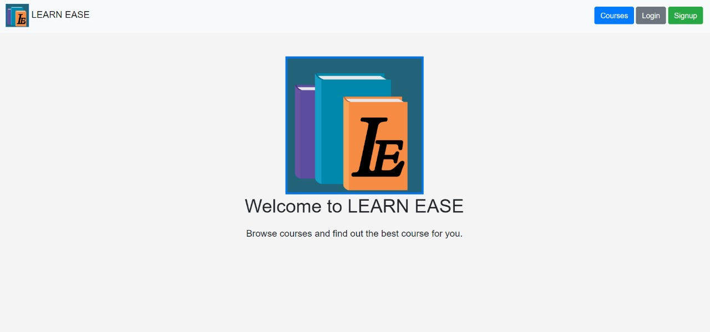

COURSES:

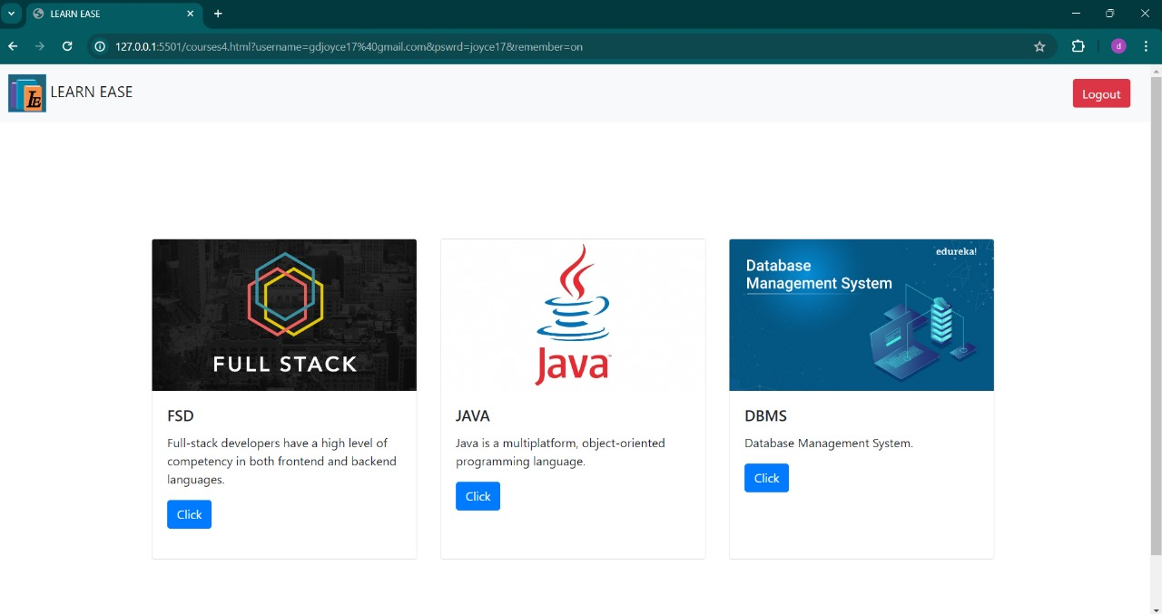

SIGNUP PAGE:

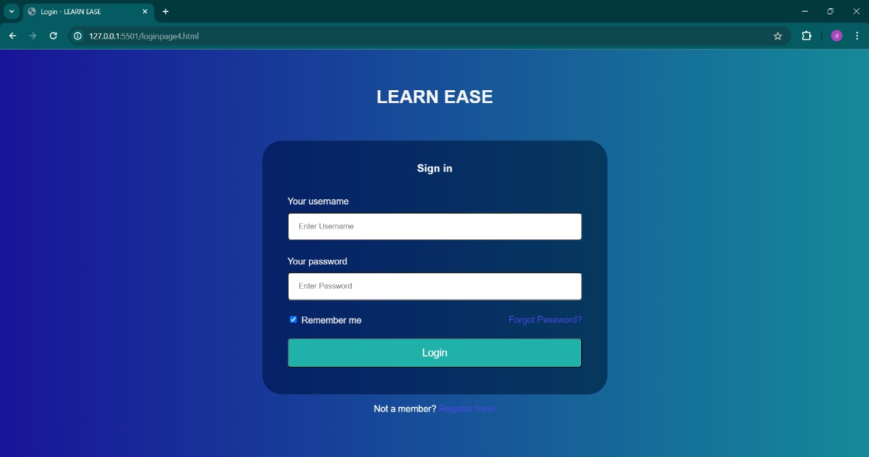

LOGIN PAGE:

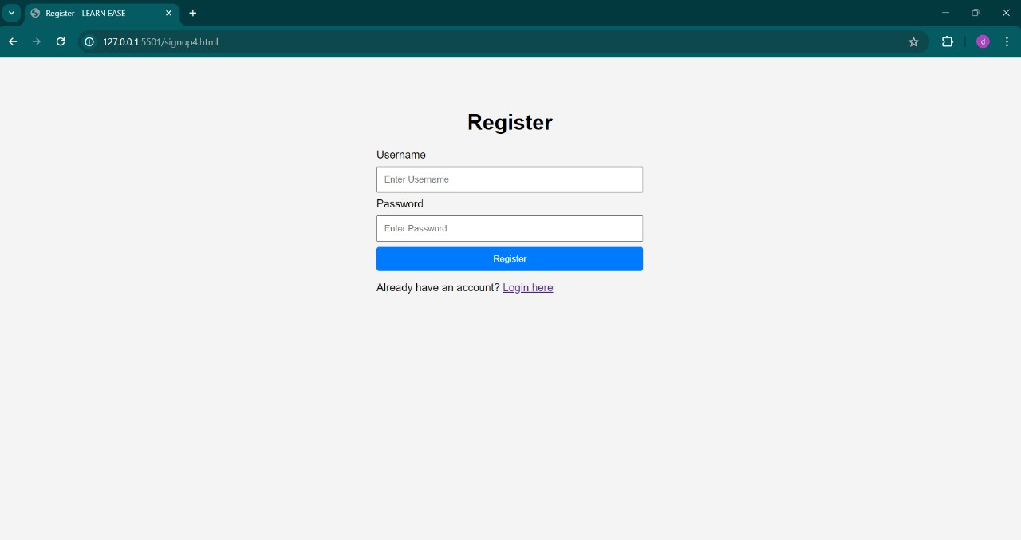

QUIZ, ASSIGNMENT SUBMISSION & DAILY QUESTION:

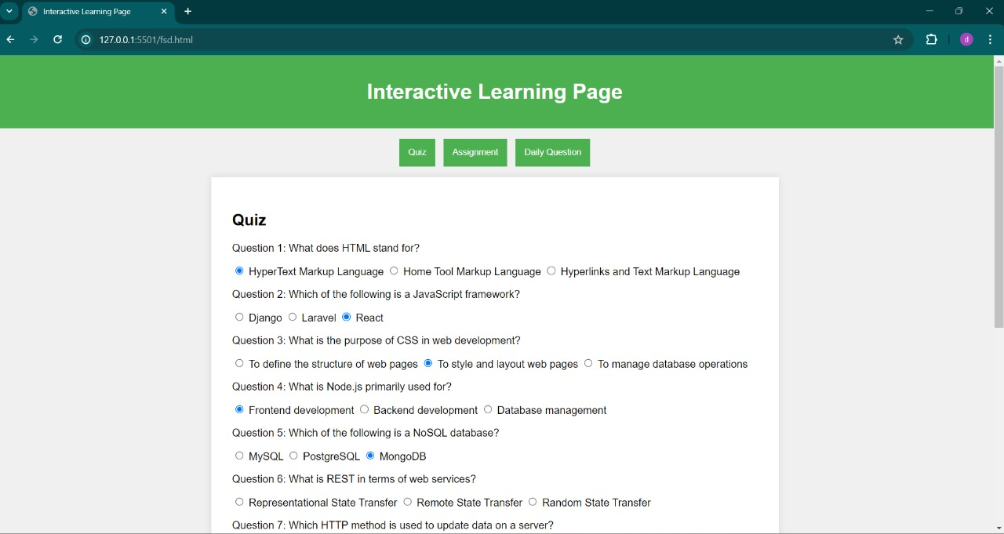

FUTURE SCOPE:

• **Advanced Analytics and Insights**: Implement advanced analytics to track user engagement, performance trends, and content effectiveness. Insights derived from this data can help in optimizing quizzes, assignments, and daily questions to better cater to student needs

• **Personalized Learning Paths**: Introduce algorithms that analyze user performance and preferences to tailor learning paths for individual students. This could involve recommending specific quizzes, assignments, or study materials based on their strengths, weaknesses, and learning goals.

• **Mobile Application Development**: Extend the platform's accessibility by developing mobile applications for iOS and Android devices. This allows students to access learning materials, quizzes, and assignments on-the-go, enhancing convenience and flexibility.

CONCLUSION:

Learn Ease is a comprehensive platform designed to centralize the preparation process for students aiming for placements. By integrating various features such as secure authentication, interactive dashboards, quizzes, assignments, daily questions, communication tools, and detailed analytics, the portal ensures a user-friendly and efficient learning experience. The inclusion of placement questions further enhances the platform's utility, making it an essential tool for students preparing for their careers.